# **Question-1**

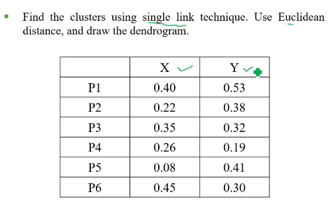

# **Question-2**

